

ECSI 407 Web Technology

Course Work-01

Soccer Shop

Group members

Dulaj Rangana – 2014166

Samitha Udakara – 2015291

Tharindu Prabashwara – 2015294

Sankalpa Nananyakkara – 2015318

Hemal Herath – 2015327

**1.Acknowledgement**

We like to thank our Web Technology lecturer, Mrs Aloka Fernando for providing us the knowledge and for guiding us through to complete this project. We can say firmly with no doubts at all, that this project has immensely helped us to improve our knowledge regarding the subject.

**2.Introduction**

We created the website “Soccer Shop” which is an online store for the soccer items such as jerseys, footballs, gloves etc. This website contains Contact forums, a shopping cart, Google maps, testimonials page and team CVs. Users can go through product pages, order items, check in their items and get a bill for their purchases in.

This project was done by Tharindu Prabhashwara, Dulaj Rangana, Samitha Udakara, Sithum Sankalpa and Nuwan Hemal.

# 3.Table of Contents

**1.ACKNOWLEDGEMENT------------------------------------------------------------------------------------------------2**

**2.INTRODUCTION ---------------------------------------------------------------------------------------------------------2**

**3.TABLE OF CONTENTS -------------------------------------------------------------------------------------------------3**

**4.TABLE OF LIST--------------------------------------------------------------------------------------------------------------3**

**5.SOURCE CODES------------------------------------------------------------------------------------------------------- 4-19**

**6.SCREEN SHOTS -------------------------------------------------------------------------------------------------------20-24**

**7.WORKLOAD MATRIX ------------------------------------------------------------------------------------------------25**

**8.FILE ARCHITECTURE -----------------------------------------------------------------------------------------------26 9.SUMMARY----------------------------------------------------------------------------------------------------------------27**

**4.List of Figures**

|  |  |  |
| --- | --- | --- |
| Figure number | Details | Page number |
| 01 | Home Page | 37 |
| 02 | Login Page | 38 |
| 03 | Signup Page | 38 |
| 04 | Shopping cart(main view) | 39 |
| 05 | CV | 40 |
| 06 | Quiz | 41 |
| 07 | Work load Matrix | 42 |
| 08 | File Architecture | 43 |

**5.Source Codes**

Home page

<!DOCTYPE html>

<html lang="en">

<head>

<!-- inporting themes from boostrap -->

<title>Premier Soccer Shop</title>

<meta charset="utf-8">

<meta name="viewport" content="width=device-width, initial-scale=1">

<link rel="stylesheet" href="http://maxcdn.bootstrapcdn.com/bootstrap/3.3.7/css/bootstrap.min.css">

<link href="http://fonts.googleapis.com/css?family=Lato" rel="stylesheet" type="text/css">

<link href="http://fonts.googleapis.com/css?family=Montserrat" rel="stylesheet" type="text/css">

<script src="https://ajax.googleapis.com/ajax/libs/jquery/1.12.4/jquery.min.js"></script>

<script src="http://maxcdn.bootstrapcdn.com/bootstrap/3.3.7/js/bootstrap.min.js"></script>

</head>

<body id="myPage" data-spy="scroll" data-target=".navbar" data-offset="50">

<nav class="navbar navbar-default navbar-fixed-top">

<div class="container-fluid">

<div class="navbar-header">

<button type="button" class="navbar-toggle" data-toggle="collapse" data-target="#myNavbar">

<span class="icon-bar"></span>

<span class="icon-bar"></span>

<span class="icon-bar"></span>

</button>

<a class="navbar-brand" href="#myPage">PREMIER SOCCER</a> <!-- navigate to home page -->

</div>

<div class="collapse navbar-collapse" id="myNavbar">

<ul class="nav navbar-nav navbar-right">

<li><a href="#myPage">HOME</a></li> <!-- navigate to home page -->

<li><a href="Login/index.html">SHOP</a></li> <!-- navigate to login page then to the cart -->

<li><a href="#tour">OFFERINGS</a></li> <!-- new discount prices -->

<li><a href="#band">TEAM</a></li> <!-- navigate to team members information page -->

<li><a href="QUIZ/Quiz.html">QUIZ</a></li> <!-- navigate to quiz page -->

<li><a href="#contact">CONTACT</a></li> <!-- navigate to comments and contact page -->

<li class="dropdown">

<a class="dropdown-toggle" data-toggle="dropdown" href="#">CV's

<span class="caret"></span></a>

<ul class="dropdown-menu"> <!-- cv informations -->

<li><a href="cv/dulaj.html">Dulaj</a></li>

<li><a href="cv/Samitha.html">Samitha</a></li>

<li><a href="cv/wanni.html">Tharindu</a></li>

<li><a href="cv/Sithum.html">Sankalpa</a></li>

<li><a href="cv/Hemal.html">Hemal</a></li>

</ul>

</li>

<li><a href="#"><span class="glyphicon glyphicon-search"></span></a></li>

</ul>

</div>

</div>

</nav>

<!-- Slide changing -->

<div id="myCarousel" class="carousel slide" data-ride="carousel">

<!-- Indicators -->

<ol class="carousel-indicators">

<li data-target="#myCarousel" data-slide-to="0" class="active"></li>

<li data-target="#myCarousel" data-slide-to="1"></li>

<li data-target="#myCarousel" data-slide-to="2"></li>

</ol>

<!-- Wrapper for slides -->

<div class="carousel-inner" role="listbox">

<div class="item active">

<img src="HomePagePics/adidas.jpg" alt="adidas" width="1200" height="700">

<div class="carousel-caption">

<h3>Adidas</h3>

<p>Shop our brand new adidas men and women soccer collection.</p>

</div>

</div>

<div class="item">

<img src="HomePagePics/nike.jpg" alt="Chicago" width="1200" height="700">

<div class="carousel-caption">

<h3>Nike</h3>

<p>new nike men and women soccer collection.</p>

</div>

</div>

<div class="item">

<img src="HomePagePics/puma.jpg" alt="Los Angeles" width="1200" height="700">

<div class="carousel-caption">

<h3>puma</h3>

<p>new items available for men and women</p>

</div>

</div>

</div>

<!-- Left and right controls -->

<a class="left carousel-control" href="#myCarousel" role="button" data-slide="prev">

<span class="glyphicon glyphicon-chevron-left" aria-hidden="true"></span>

<span class="sr-only">Previous</span> <!-- navigate to left slide -->

</a>

<a class="right carousel-control" href="#myCarousel" role="button" data-slide="next">

<span class="glyphicon glyphicon-chevron-right" aria-hidden="true"></span> <!-- navigate to right slide -->

<span class="sr-only">Next</span>

</a>

</div>

<!-- Container -->

<!-- Information about the shop -->

<div id="band" class="container text-center">

<h3>Premier Soccer</h3>

<p><em>Give your soccer items a second chance!</em></p>

<p>THE premier Soccer is the soccer store for all your soccer equipment and apparel needs! Our mission is to offer the best products and services that

inspire soccer players to elevate their game and play with passion and confidence.

THE Premier Soccer strives to provide the best soccer shopping experience to both the Dallas / Fort Worth and Austin community and the national soccer fan.

THE Premier Soccer is a leading dealer of soccer equipment for all levels of soccer player, including recreational, club, and school. Our online soccer

shop has thousands of items to fulfil all your player, coaching, or fan based needs. In addition to our online soccer store, PrmierSoccer.com</p>

<br>

<!-- Pictures and personel interest of group members -->

<div class="row">

<div class="col-sm-4">

<p class="text-center"><strong>Sankalpa</strong></p><br>

<a href="#demo" data-toggle="collapse">

<img src="HomePagePics/sankalpa.jpg" class="img-circle person" alt="sankalpa" width="255" height="255">

</a>

<div id="demo" class="collapse">

<p>Sithum Sankalpa Nanayakkara</p>

<p>Born in 1996-12-12</p>

<p>Went to St Benedict's college</p>

<p>Following a software engineering degree at IIT</p>

</div>

</div>

<div class="col-sm-4">

<p class="text-center"><strong>Dulaj</strong></p><br>

<a href="#demo2" data-toggle="collapse">

<img src="HomePagePics/dulaj.jpg" class="img-circle person" alt="Random Name" width="255" height="255">

</a>

<div id="demo2" class="collapse">

<p>Dulaj Gamage</p>

<p>Born in 1995-03-07</p>

<p>Went to St Sebastian College</p>

<p>Following a software engineering degree at IIT</p>

</div>

</div>

</div>

<!-- Container special offer section -->

<div id="tour" class="bg-1">

<div class="container">

<h3 class="text-center">SPECIAL OFFERS</h3>

<p class="text-center">Premier Soccer shop will give you massive discounts<br> Until 31<sup>st</sup> December!</p>

<!-- adidas ball information -->

<div class="row text-center">

<div class="col-sm-4">

<div class="thumbnail">

<img src="HomePagePics/ball.jpg" alt="adidas" width="400" height="300">

<p><strong>Adidas football</strong></p>

<p>30% discount</p>

<button class="btn" data-toggle="modal" data-target="#myModal">Buy Now</button>

</div>

</div>

<!-- nike shoe information -->

<div class="col-sm-4">

<div class="thumbnail">

<img src="HomePagePics/nshoe.jpg" alt="Nike" width="400" height="300">

<p><strong>Nike shoe</strong></p>

<p>10% discount </p>

<button class="btn" data-toggle="modal" data-target="#myModal">Buy Now</button>

</div>

</div>

<!-- puma gloves information -->

<div class="col-sm-4">

<div class="thumbnail">

<img src="HomePagePics/pgloves.jpg" alt="puma" width="400" height="300">

<p><strong>Puma gloves</strong></p>

<p>25% discount</p>

<button class="btn" data-toggle="modal" data-target="#myModal">Buy Now</button>

</div>

</div>

</div>

</div>

<!-- Modal -->

<div class="modal fade" id="myModal" role="dialog">

<div class="modal-dialog">

<!-- Modal content-->

<div class="modal-content">

<div class="modal-header">

<button type="button" class="close" data-dismiss="modal">×</button>

<h4><span class="glyphicon glyphicon-lock"></span> Online Pay</h4>

</div>

<div class="modal-body">

<form role="form">

<div class="form-group">

<label for="psw"><span class="glyphicon glyphicon-shopping-cart"></span> No of Items</label>

<input type="number" class="form-control" id="psw" placeholder="How many?">

</div>

<div class="form-group">

<label for="usrname"><span class="glyphicon glyphicon-user"></span>Country code</label>

<input type="text" class="form-control" id="usrname" placeholder="Enter your country code">

</div>

<button type="submit" class="btn btn-block" data-target="#myPage">Pay

<span class="glyphicon glyphicon-ok"></span>

</button>

</form>

</div>

<div class="modal-footer">

<button type="submit" class="btn btn-danger btn-default pull-left" data-dismiss="modal">

<span class="glyphicon glyphicon-remove"></span> Cancel

</button>

<p>Need <a href="https://countrycode.org/" target="_blank">help?</a></p>

</div>

</div>

</div>

</div>

</div>

<!-- Container (Contact Section) -->

<div id="contact" class="container">

<h3 class="text-center">Contact</h3>

<p class="text-center"><em>We love our fans!</em></p>

<div class="row">

<div class="col-md-4">

<p>Fan? Drop a note.</p>

<p><span class="glyphicon glyphicon-map-marker"></span>Soccer Shop</p>

<p><span class="glyphicon glyphicon-phone"></span>Phone: +94 15506756</p>

<p><span class="glyphicon glyphicon-envelope"></span>Email: Soccershop@gmail.com</p>

</div>

<!-- getting comments from the customer -->

<div class="col-md-8">

<div class="row">

<form action="" method="POST">

<div class="col-sm-6 form-group">

<input class="form-control" id="name" name="Name" placeholder="Name" type="text" required>

</div>

<div class="col-sm-6 form-group">

<input class="form-control" id="email" name="email" placeholder="Email" type="email" required>

</div>

</div>

<textarea class="form-control" id="comments" name="Comment" placeholder="Comment" rows="5"></textarea>

<br>

<div class="row">

<div class="col-md-12 form-group">

<!-- <button class="btn pull-right" type="submit">Send</button>-->

<input type="submit" name="Submit" value="Submit Comment" class="btn pull-right">

</div>

</div>

</form>

</div>

</div>

<?php

if($_POST['Submit']){

print "<h1>Your comment has been submitted!</h1>";

#Geting names and comments by name

$Name = $_POST['Name'];

$Comment = $_POST['Comment'];

#Get old comments

$old = fopen("comments.txt", "r+t");

$old_comments = fread($old, 1024);

#Delete everything, write down new and old comments

$write = fopen("comments.txt", "w+");

$string = "<b>".$Name."</b><br><ul>".$Comment."</ul><hr>\n".$old_comments; #writing the comments to the comments.txt

fwrite($write, $string);

fclose($write);

fclose($old);

}

#Read comments

$read = fopen("comments.txt", "r+t");

echo "<br><br>Comments<hr>".fread($read, 1024);

fclose($read);

?>

<br>

<!-- Contact information of our team members-->

<h3 class="text-center">From The Blog</h3>

<ul class="nav nav-tabs">

<li class="active"><a data-toggle="tab" href="#home">Sankalpa</a></li>

<li><a data-toggle="tab" href="#menu1">Samitha</a></li>

<li><a data-toggle="tab" href="#menu2">Dulaj</a></li>

<li><a data-toggle="tab" href="#menu3">Tharindu</a></li>

<li><a data-toggle="tab" href="#menu4">Hemal</a></li>

</ul>

<div class="tab-content">

<div id="home" class="tab-pane fade in active">

<h2>Sankalpa Nanayakkara</h2>

<p>No.280/B, Pattiyawala, Wattala</p>

<p>sithtumsankalpa@gmail.com</p>

<p>075-5643786</p>

</div>

<div id="menu1" class="tab-pane fade">

<h2>Samitha Udakara</h2>

<p>No.76/3,Piliyandala,Colombo</p>

<p>samithaudakara@gmail.com</p>

<p>071-1643486</p>

</div>

</div>

<div id="googleMap"></div>

<!-- Add Google Maps -->

<script src="http://maps.googleapis.com/maps/api/js"></script>

<script>

var myCenter = new google.maps.LatLng(6.865320, 79.859823); <!-- get longitudes and latitudes -->

function initialize() {

var mapProp = {

center:myCenter,

zoom:12,

scrollwheel:false,

draggable:false,

mapTypeId:google.maps.MapTypeId.ROADMAP

};

var map = new google.maps.Map(document.getElementById("googleMap"),mapProp);

var marker = new google.maps.Marker({

position:myCenter,

});

marker.setMap(map);

}

google.maps.event.addDomListener(window, 'load', initialize);

</script>

<!-- Footer -->

<footer class="text-center">

<a class="up-arrow" href="#myPage" data-toggle="tooltip" title="TO TOP">

<span class="glyphicon glyphicon-chevron-up"></span>

</a><br><br>

</footer>

<script>

$(document).ready(function(){

// Initialize Tooltip

$('[data-toggle="tooltip"]').tooltip();

// Add smooth scrolling to all links in navbar + footer link

$(".navbar a, footer a[href='#myPage']").on('click', function(event) {

// Make sure this.hash has a value before overriding default behavior

if (this.hash !== "") {

// Prevent default anchor click behavior

event.preventDefault();

// Store hash

var hash = this.hash;

// Using jQuery's animate() method to add smooth page scroll

// The optional number (900) specifies the number of milliseconds it takes to scroll to the specified area

$('html, body').animate({

scrollTop: $(hash).offset().top

}, 900, function(){

// Add hash (#) to URL when done scrolling (default click behavior)

window.location.hash = hash;

});

} // End if

});

})

</script>

</body>

</html>

Shopping cart

<?php

session_start();

require_once 'db.php';

$db = new DB();

// check cookie exist

if ( isset( $_COOKIE['sids']) && $_COOKIE['sids'] !='') {

$aids = explode(',',$_COOKIE['sids']) ;

// validate data

foreach ($aids as $k => $val) {

if (!is_numeric($val)) {

unset($aids[$k]);

}

}

$products = $db->getListProductByListIds($aids);

// init session from cookie.

foreach ($products as $item) {

if (!isset($_SESSION['cart_info'][$item['id']]) ) {

$temp = [];

$temp['id'] = $item['id'];

$temp['name'] = $item['name'];

$temp['cost'] = $item['cost'];

$temp['image'] = $item['image'];

$temp['quantity'] = 1; // default

$_SESSION['cart_info'][$item['id']] = $temp;

}

}

}

?>

<!DOCTYPE html>

<html lang="en">

<head>

<meta charset="utf-8">

<meta name="viewport" content="width=device-width, initial-scale=1.0">

<meta name="description" content="">

<meta name="author" content="">

<title>World Soccer Shop</title>

<link href="css/bootstrap.min.css" rel="stylesheet">

<link href="css/font-awesome.min.css" rel="stylesheet">

<link href="css/prettyPhoto.css" rel="stylesheet">

<link href="css/price-range.css" rel="stylesheet">

<link href="css/animate.css" rel="stylesheet">

<link href="css/main.css" rel="stylesheet">

<link href="css/responsive.css" rel="stylesheet">

</head><!--/head-->

<body>

<header id="header"><!--header-->

<div class="header_top"><!--header_top-->

<div class="container">

<div class="row">

<div class="col-sm-6 ">

<div class="contactinfo">

<ul class="nav nav-pills">

<li><a href="tel:+84973710159"><i class="fa fa-phone"></i> +94 72 122 1484 </a></li>

<li><a href="mailto:quyentv209@gmail.com"><i class="fa fa-envelope"></i> dmaxrodrigo1@gmail.com</a></li>

</ul>

</div>

</div>

<div class="col-sm-6">

<div class="social-icons pull-right">

<ul class="nav navbar-nav">

<li><a href=""><i class="fa fa-facebook"></i></a></li>

<li><a href=""><i class="fa fa-twitter"></i></a></li>

<li><a href=""><i class="fa fa-linkedin"></i></a></li>

<li><a href=""><i class="fa fa-dribbble"></i></a></li>

<li><a href=""><i class="fa fa-google-plus"></i></a></li>

</ul>

</div>

</div>

</div>

</div>

</div><!--/header_top-->

<div class="header-middle"><!--header-middle-->

<div class="container">

<div class="row">

<div class="col-sm-4">

<div class="logo pull-left">

<h3>World Soccer Shop</h3>

</div>

</div>

<div class="col-sm-8">

<div class="shop-menu pull-right">

<ul class="nav navbar-nav">

<li><a href="cart.html"><i class="fa fa-shopping-cart"></i> Cart</a></li>

</ul>

</div>

</div>

</div>

</div>

</div><!--/header-middle-->

<div class="header-bottom"><!--header-bottom-->

<div class="container">

<div class="row">

<div class="col-sm-9">

<div class="navbar-header">

<button type="button" class="navbar-toggle" data-toggle="collapse" data-target=".navbar-collapse">

<span class="sr-only">Toggle navigation</span>

<span class="icon-bar"></span>

<span class="icon-bar"></span>

<span class="icon-bar"></span>

</button>

</div>

<div class="mainmenu pull-left">

<ul class="nav navbar-nav collapse navbar-collapse">

<li><a href="index.php">Shop</a></li>

<li><a href="cart.php">Cart</a></li>

</ul>

</div>

</div>

<div class="col-sm-3">

<div class="search_box pull-right">

<input placeholder="Search" type="text">

</div>

</div>

</div>

</div>

</div>

</header>

<section>

<div class="container">

<div class="row">

<div class="col-sm-3">

<div class="left-sidebar">

<h1>Categories</h1>

<div id="accordian" class="panel-group category-products"><!--category-productsr-->

<div class="panel panel-default">

<p> Balls </p>

</div>

<div class="panel panel-default">

<p> Shoes </p>

</div>

<div class="panel panel-default">

<p> Pads </p>

</div>

<div class="panel panel-default">

<p> Jerseys </p>

</div>

<div class="panel panel-default">

<p> Shorts </p>

</div>

<div class="panel panel-default">

<p> Gloves </p>

</div>

<div class="panel panel-default">

<p> Goal Nets </p>

</div>

<div class="panel panel-default">

<p> Stokings </p>

</div>

</div><!--/category-productsr-->

</div>

</div>

<div class="col-sm-9 padding-right">

<div class="table-responsive cart_info">

<table class="table table-condensed">

<thead>

<tr class="cart_menu">

<td class="image">Item</td>

<td class="description"></td>

<td class="price">Price</td>

<td class="quantity">Quantity</td>

<td class="total">Total</td>

<td></td>

</tr>

</thead>

<tbody>

<!-- show product in cart -->

<?php if ( !isset($_SESSION['cart_info']) || empty($_SESSION['cart_info']) ): ?>

<tr>

<td colspan="20"> <h4>Cart empty</h4> </td>

</tr>

<?php else: ?>

<?php $payment_total = 0;?>

<?php foreach($_SESSION['cart_info'] as $item): ?>

<tr>

<td class="cart_product">

<a href=""><img style="width: 70px; height: 80px" alt="" src="<?php echo $item['image']?>"></a>

</td>

<td class="cart_description">

<h4><a href=""><?php echo $item['name']?></a></h4>

<p>ID: <?php echo $item['id']?> </p>

</td>

<td class="cart_price">

<p>$<?php echo $item['cost']?></p>

</td>

<td class="cart_quantity">

<div class="cart_quantity_button">

<?php echo dropdown_select('quantity', $item['quantity'], $item['id'] );?>

<!--<select rel="3" class="quantity" name="quantity3" id="quantity3">

<option value="1">1</option>

<option value="2">2</option>

<option value="3">3</option>

<option value="4">4</option>

<option value="5">5</option>

<option value="6">6</option>

<option value="7">7</option>

<option value="8">8</option>

<option selected="selected" value="9">9</option>

<option value="10">10</option>

</select>-->

</div>

</td>

<td class="cart_total">

<p id="total-item-<?php echo $item['id']?>" class="cart_total_price">$<?php echo $item['cost'] * $item['quantity'];?></p>

</td>

<td class="cart_delete">

<a href="javascript:void(0);" ref="<?php echo $item['id']?>" class="cart_quantity_delete"><i class="fa fa-times"></i></a>

</td>

</tr>

<?php $payment_total += $item['cost'] * $item['quantity']; ?>

<?php endforeach; ?>

<tr>

<td colspan="10"><b>Total: </b><b id="payment-total">$<?php echo $payment_total; ?></b></td>

</tr>

<?php endif;?>

</tbody>

</table>

</div>

</div>

</div>

</div>

</section>

<footer id="footer"><!--Footer-->

<div class="footer-bottom">

<div class="container">

<div class="row">

<p class="pull-left">Copyright © 2016 SriLanka. All rights reserved.</p>

</div>

</div>

</div>

</footer><!--/Footer-->

<script src="js/jquery.js"></script>

<script src="js/functions.js"></script>

</body>

</html>

**6.Screen Shots**

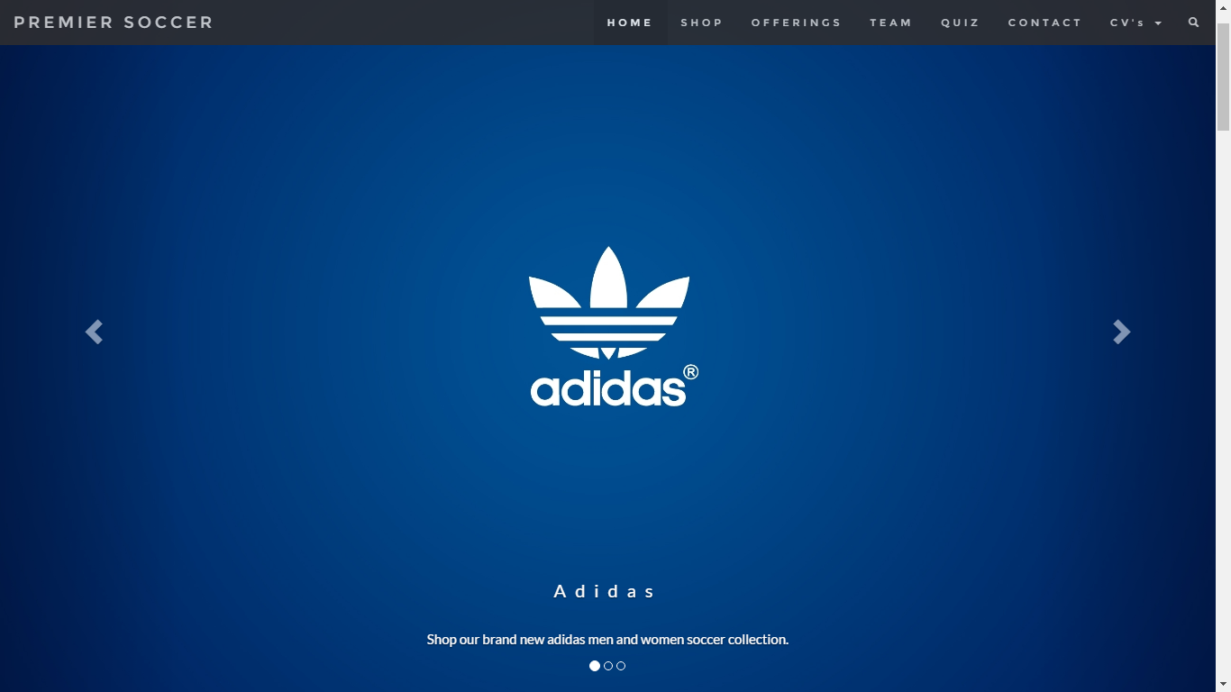

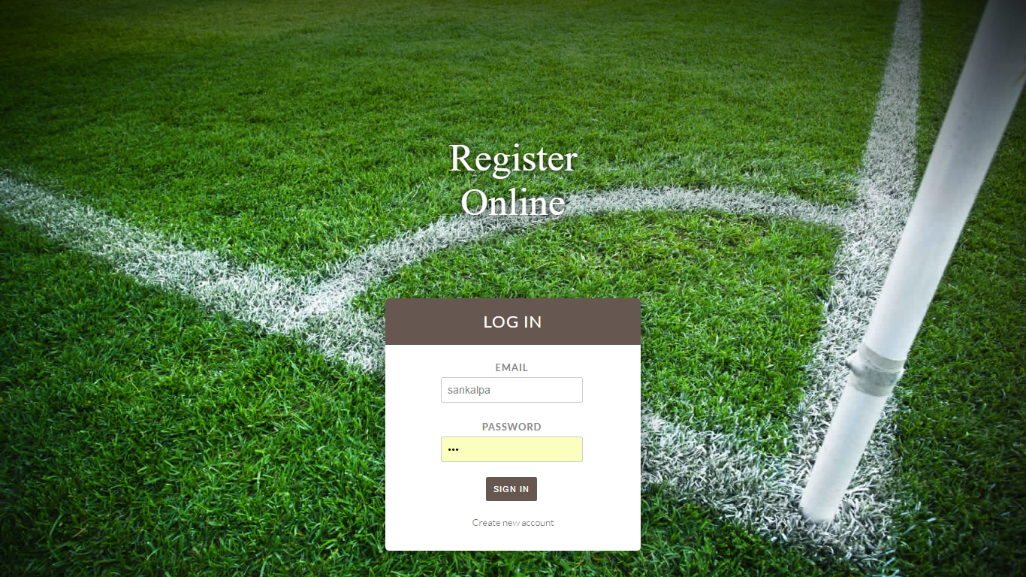

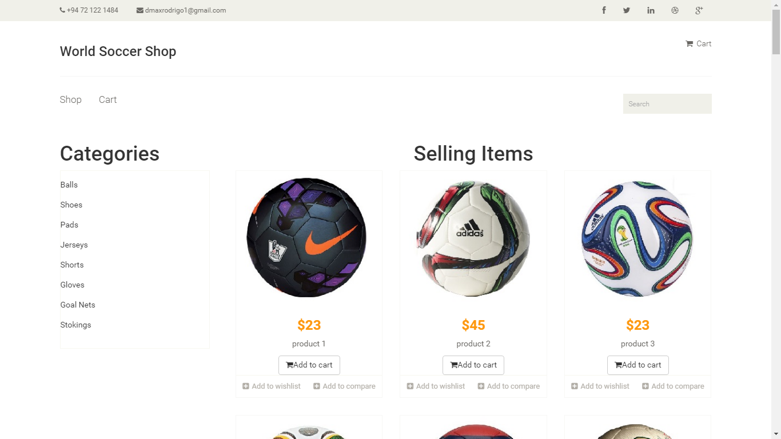

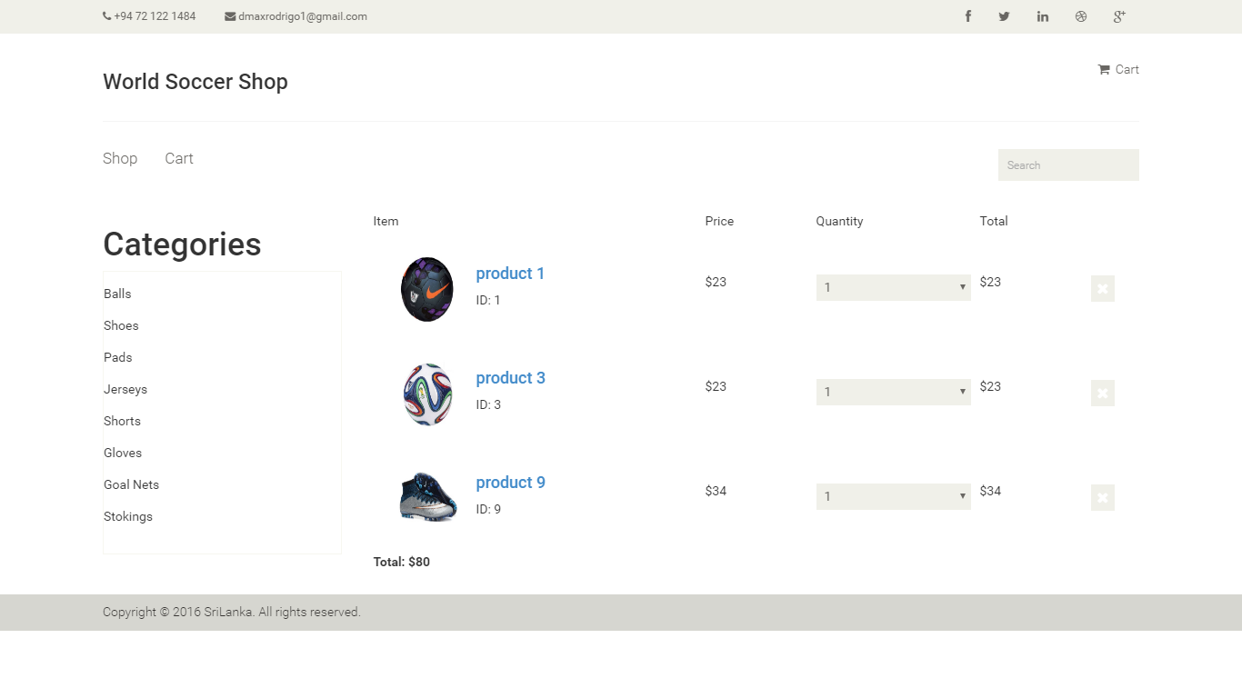

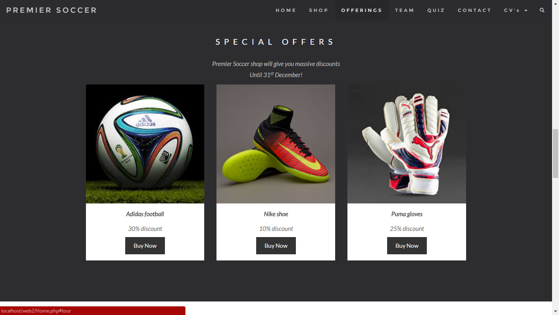

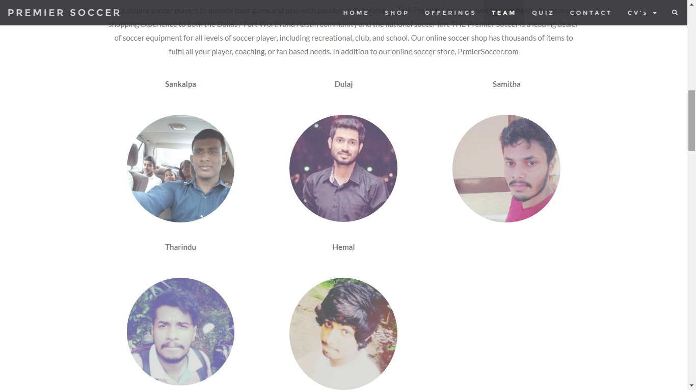

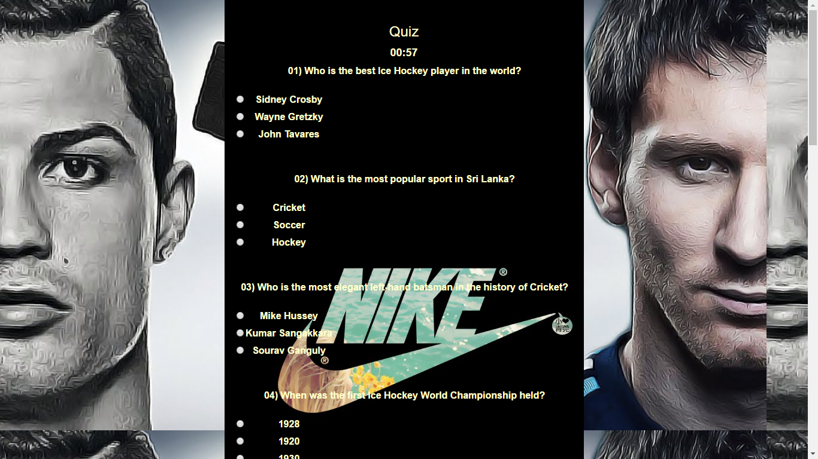

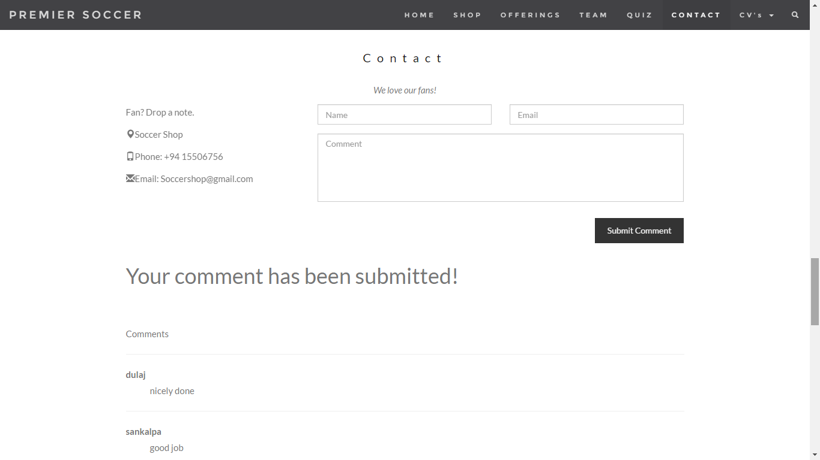

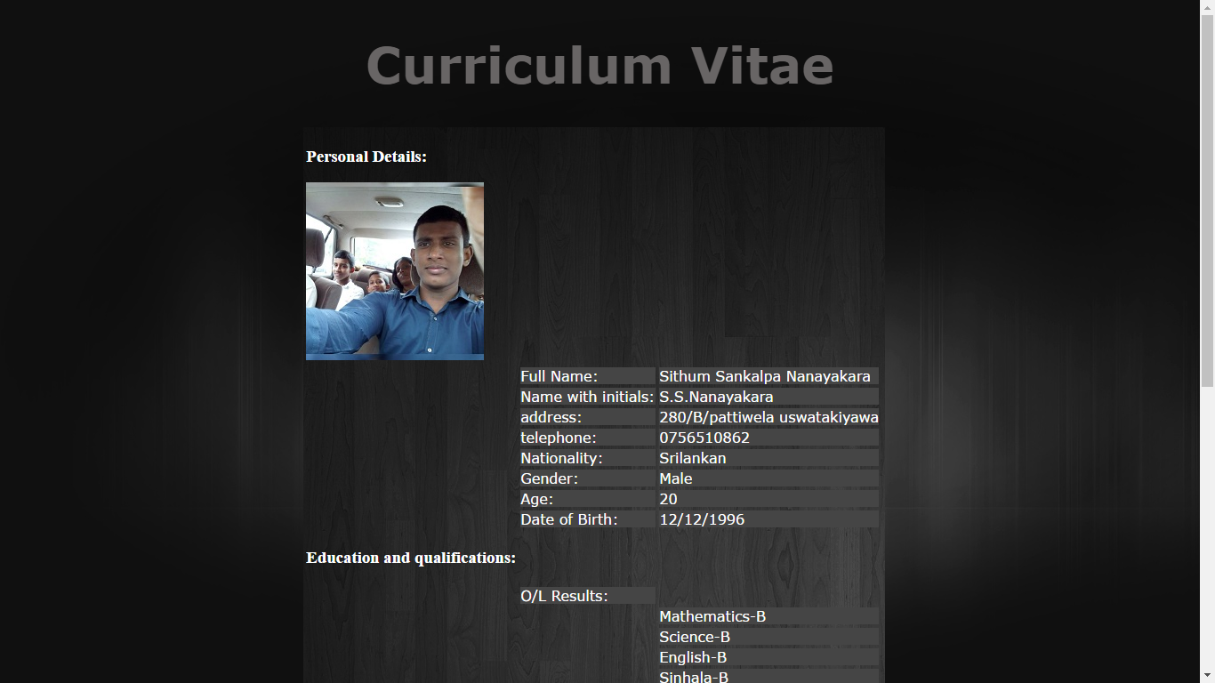

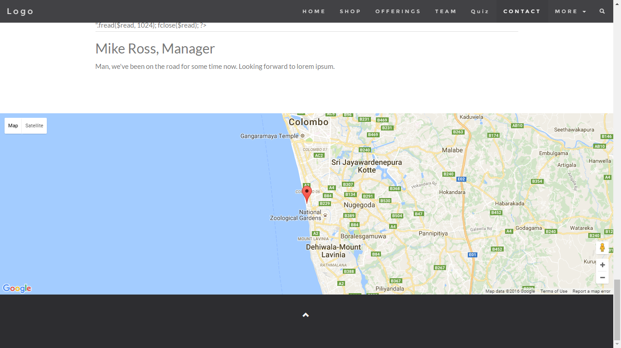

# 7.Workload Matrix

|  |  |  |
| --- | --- | --- |
| **Task**  **Id** | **Task Name** | **Contributed Person/s** |
| 1 | Front page | Name : Samitha Udakara |
| 2 | Sign up  Log in  Data Base | Name : Sankalpa |
| 3 | Home Page  Quiz  Contact Us | Names : Hemal  Sankalpa |
| 4 | Google map  Testimonials page | Name : Tharindu  Sankalpa |
| 5 | Shopping Cart | Names : Gamage Dulaj  Smaitha Udakara  Tharindu Prabashwara |
| 6 | Cv’s  Documentation | Name:Tharindu |

# 8.File Architecture

# 

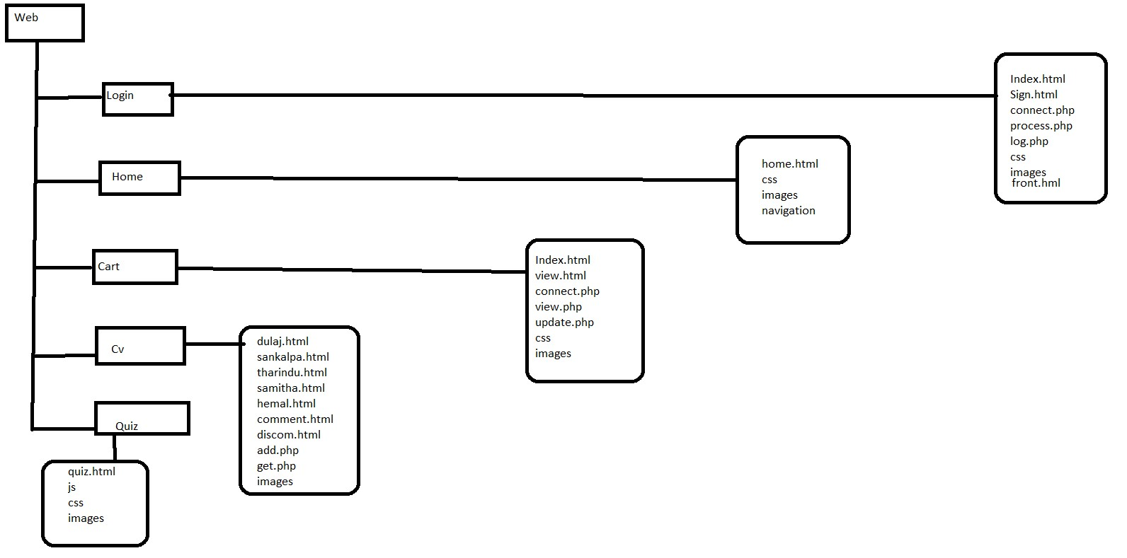

# 9.SUMMARY

In this project we developed a web site with full functioning. We used languages like HTML ,

PHP , JAVA SCRIPT , CSS and MY SQL to implement the code. By creating online web sites like this we can market it to the out siders and earn profits. And also we learned how to solve lot of difficult palaces which we faced at the computer programming. So we think this will be help for our future.